King Abdullah II School of Information Technology

Computer Skills2

Problem Solving Homework

اخر موعد لتسليم الواجب 9-10-2012

Choose the correct answer for each of the following questions:

 | Question | Choice 1 | Choice 2 | Choice 3 | Choice 4
1. | If the value of z is 2.1 x 10⁻³, then the data type of the z is: | Integer | Real | String | Boolean
2. | The data type of the following value "-3.5*10^4" is: | Integer | Real | String | Boolean
3. | One of the following assignment statements is correct | y+1=3+x | A+2= 4 | A = B | 22=A
4. | The value of Y after solving the following equation is:  Y = 3*2-10+5-(4*1+2^-2*4) | -4 | 5 | 11 | 7
5. | The value of X after solving the following equation is:  X= 16+3mod7*2-4mod 3 | 21 | 17 | 18 | 11
6. | The value of A after solving the following equation is:  A= 4*(5*2^2/5+1)/(4+1)+2^4-9 | 39 | 9 | 10 | 11
7. | The value of Z after solving the following equation is  Z= 6-3^2 mod 10 <7 and not(5+2*4<>12)or false | True | False | 3 | 0
8. | The value of X after solving the following equation is:  X = 10^2>100 or 2^(6-14mod8)=1 | True | False | 2 | 8
9. | The value of Y after solving the following equation is:  Y=not( 8mod10 =10mod8) or true and 3^2=3*2 | True | False | 5 | 0
10. | The output of the following flowchart is:  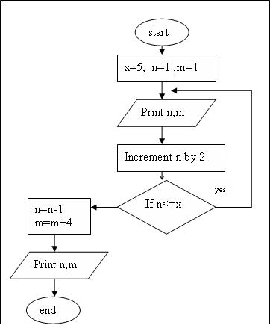 | 1 1 3 1 5 1 | 1 1 3 1 5 1 6 5 | 1 1 3 1 5 1 4 5 | None of them
11. | The structure of the flowchart in question 10 is | Looping | Selection | Sequence | Can’t Determine
12. | The equivalent Pseudo Code for the flowchart in question 10 is: | 1. Start  2. let x=5, n=1, m=1  3. print n, m  4.Increment n by 2  5.If n<=x then goto3  6.n=n-1,m=m+4  7.Print n, m  8. end | 1. Start  2. let x=5, n=1, m=1  3. print n, m  4.Increment n by 2  5.If n<=x then goto2 else n=n-1  6. m=m+4  7. end | 1. Start  2. let x=5, n=1, m=1  3. print n, m  4.Increment n by 2  5.If n<=x then n=n-1, m=m+4  6.Print n, m  7. end | None of them
13. | What are the suitable words to be filled in the blanks so that the following pseudo code will:  Print the summation of the odd numbers between 1 to 10.  - Start  - count=1  - sum=0  - sum=sum+______  - count=count+2  - if count<=10 then goto _____  - print ______  - Stop | 4. count  6. step 4  7. count | 4. 2  6. step 4  7. sum | 4. count  6. step 4  7. sum | 4. count  6. step 3  7. count
14. | What is the output for the following flowchart:  Assume that n= 10:  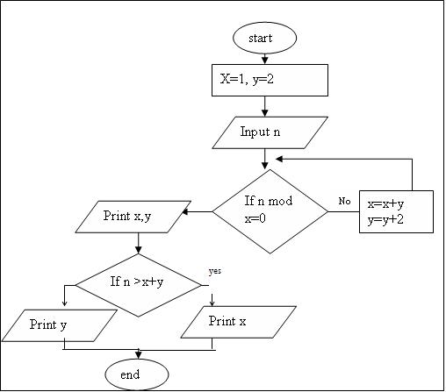 | 5 4 | 1 2 1 | 5 4 4 | None of them
15. | Which one of the following pseudo codes solve the following problem:  Printing numbers from 30 to 1 in descending order | 1.Start  2. c=30  3. Print c  4.c=c+1  5.if c>=1 then goto 3  6.stop | 1.Start  2. c=1  3. Print c  4.c=c-1  5.if c>=30 then goto 3  6.Stop | 1.Start  2. c=30  3. Print c  4.c=c-1  5.if c>=1 then goto 3  6.Stop | None of them
16. | What is the output for the following code  If the inputs are 4,7,3  - c = 5  - if c > 0 then goto 4  - goto 9  - input m  - x=m+c  - print x  - c=c-2  - goto 2  - end | 5 3 1 | 9 10 | 9 10 4 | None of them
17. | Write the equivalent Pseudo Code for the following Flowchart | 1. Let a = 6, b = 10  2. If b-a = 0 then print "good"  3. if a+b<>10 then print x else  a=a-1 ,b=b+1,  print a,b  4. end | 1. Let a = 6, b = 10  2. If b-a = 0 then print "good" else if a+b<>10 then print x else  a=a-1  b=b+1  print a,b  3. end | 1. Let a = 6, b = 10  2. If b-a = 0 then print "good"  3. if a+b<>10 then print x else  a=a-1 , b=b+1  5. print a,b  6. end | None of them
18. | What is the output for the following flowchart: | good | 2 8 | good 2 8 | None of them
19. | What is the output from the following flowchart, use the following set of Integers for the values of y:  12 5 7 9 6 4  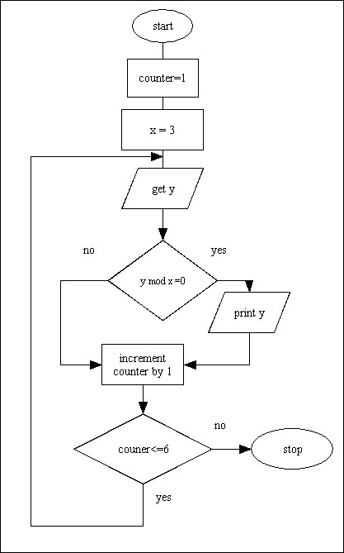 | 12 5 7 9 6 4 | 5 7 4 | 1 2 3 4 5 6 | 12 9 6
20. | The error in the following flowchart is: | The symbol used for the start statement | The symbol used for the stop statement | The symbol used for the input statement | No error
21. | The error in the following flowchart is: | The symbol used for the start statement | The symbol used for the stop statement | The symbol used for the input statement | No error

