Lec 6 / coronary arteries extra notes

Isovolumetric contraction phase :

During this phase there is no change in length of fibers , Also the inlet and outlet valves are close .

After that when BP inside the ventricles increased more than the the pressure in the aorta the aortic valve will open >>>> systemic circulation .

The coronary arteries :

They are branches of the ascending aorta

- Right coronary artery
- Left coronary artery

The right coronary artery are more important. This is because it gives the nodal artery , Which supply the SA node .

- If the blood supply to the SA node decreases , the heart will beat at 30 – 40 beat per minute instead of 70 – 80 beats per min >>> we need an artificial peacemaker

The left coronary artery gives two terminal branches :
1 – Anterior interventricular or LAD , gives >>>> diagonal artery
2 – Circumflex Artery , give >>>>> obtuse marginal artery

A - Cardiac anastomosis :
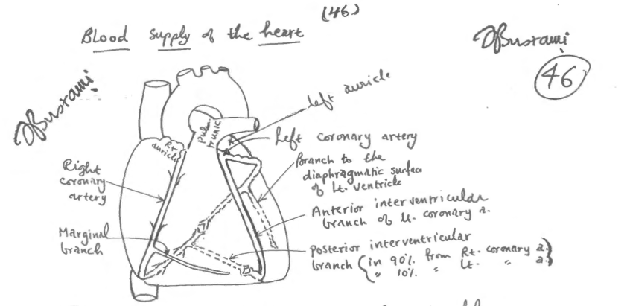

(( 1 )) The right coronary artery will anastomose with the Circumflex Artery a branch of left coronary artery and form a circle around the heart
(( RT.Coronary >>>><<<< LT.Coronary )) .

(( 2 )) Anterior interventricular artery or LAD : left anterior descending artery will anastomose with posterior intervenricular artery and form a loop around the heart .

It’s a inadequate anastomosis ( functional end artery ) .
- It is found adequate in less than 10% of normal hearts .

This ratio tend to be 40% in patients with chronic anemia .

Also it is going to be 100% in patients with previous infarction .

B – Extracardiac Anastomosis :

This anastomosis is mostly inadequate
-Bronchial and Phrenic artery are branches of the descending aorta .

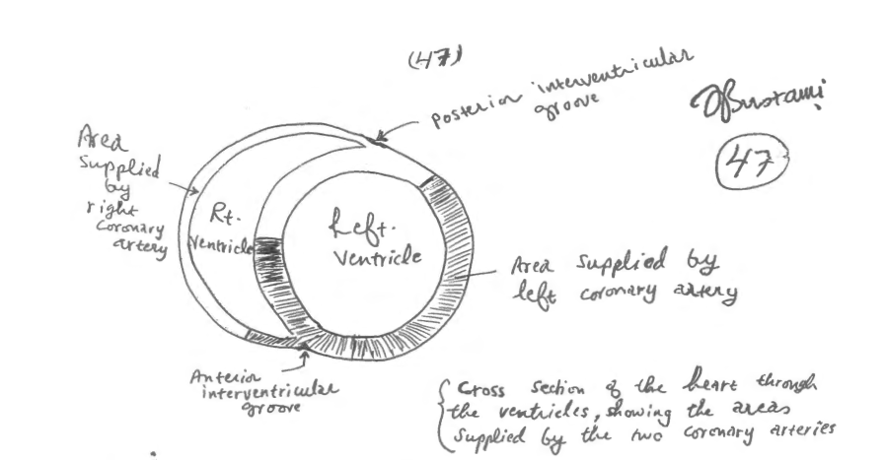

Right coronary artery supplies the posterior half of interventricular septum and also supplies all the right ventricle wall except the anterior portion near the anterior interventricular groove .

Left coronary artery supplies the anterior half of the interventricular septum. Its also supply all the left ventricle wall except the posterior portion near the posterior interventricular groove .

- Coronary Sinus :
- Starts as oblique vein of the left atrium .
Ends in the right atrium between the inferior vena cava and the tricuspid opening

# Right common cardinal vein : in fetus will develop to right superior vena cava will open in >>>> right atrium (( normal )) .

# Left common cardinal vein should be atrophied later in adult life and form
Oblique vein of Marshall . On the other hand ,if it is not going to form left superior vena cava which will drain into coronary sinus >>>> right atrium (( not directly into right atrium )) .

* The right intercostal artery are longer than the left intercostal artery. This is because the descending aorta start at the left side of T-4 vertebra and ends up at median plane of T-12 vertebra .

In order to treat atherosclerosis , in the past they used (sympathectomy) to cut 3 or 4 ganglia in the sympathetic chain in order to dilate the vessels . But after the procedure they notice the patients had a flushing in the areas , which is lose their sympathetic innervation due to increased blood flow , The point that doctor mentioned here was about that the sympathetic chain runs anterior to the right posterior intercostal artery so whenever u make sympathectomy you should careful
to avoid right posterior intercostal artery injury or cut and prevent bleeding .

Left brachiocephalic vein is longer than right brachiocephalic vein

the structures inside pericardium : from lateral to medial

left brachiocephalic vein pass anteriorly to :
1- brachiocephalic artery
- left common carotid artery
- left subclavian artery

The veins are more susceptible to compress than artery, because of their thin walls .
* obstruction of the superior vena cava is not common .

scan

*The esophagus runs anteriorly to the descending aorta .

*Enlargement of arch of aorta (( aneurism )) will compress the trachea and esophagus .

Arch of aorta :

start : sternal angle
end : T-4 vertebra
- have 2 surface :
- superficial & anterior to the left .
- deep & posterior to the right .

The right pulmonary artery passes posteriorly to the :
1- arch of aorta & 2- superior vena cava

Ligamentum arteriosum :

** the heart in fetal life was developed in the neck so that’s why it receives sympathetic innervation from the neck .

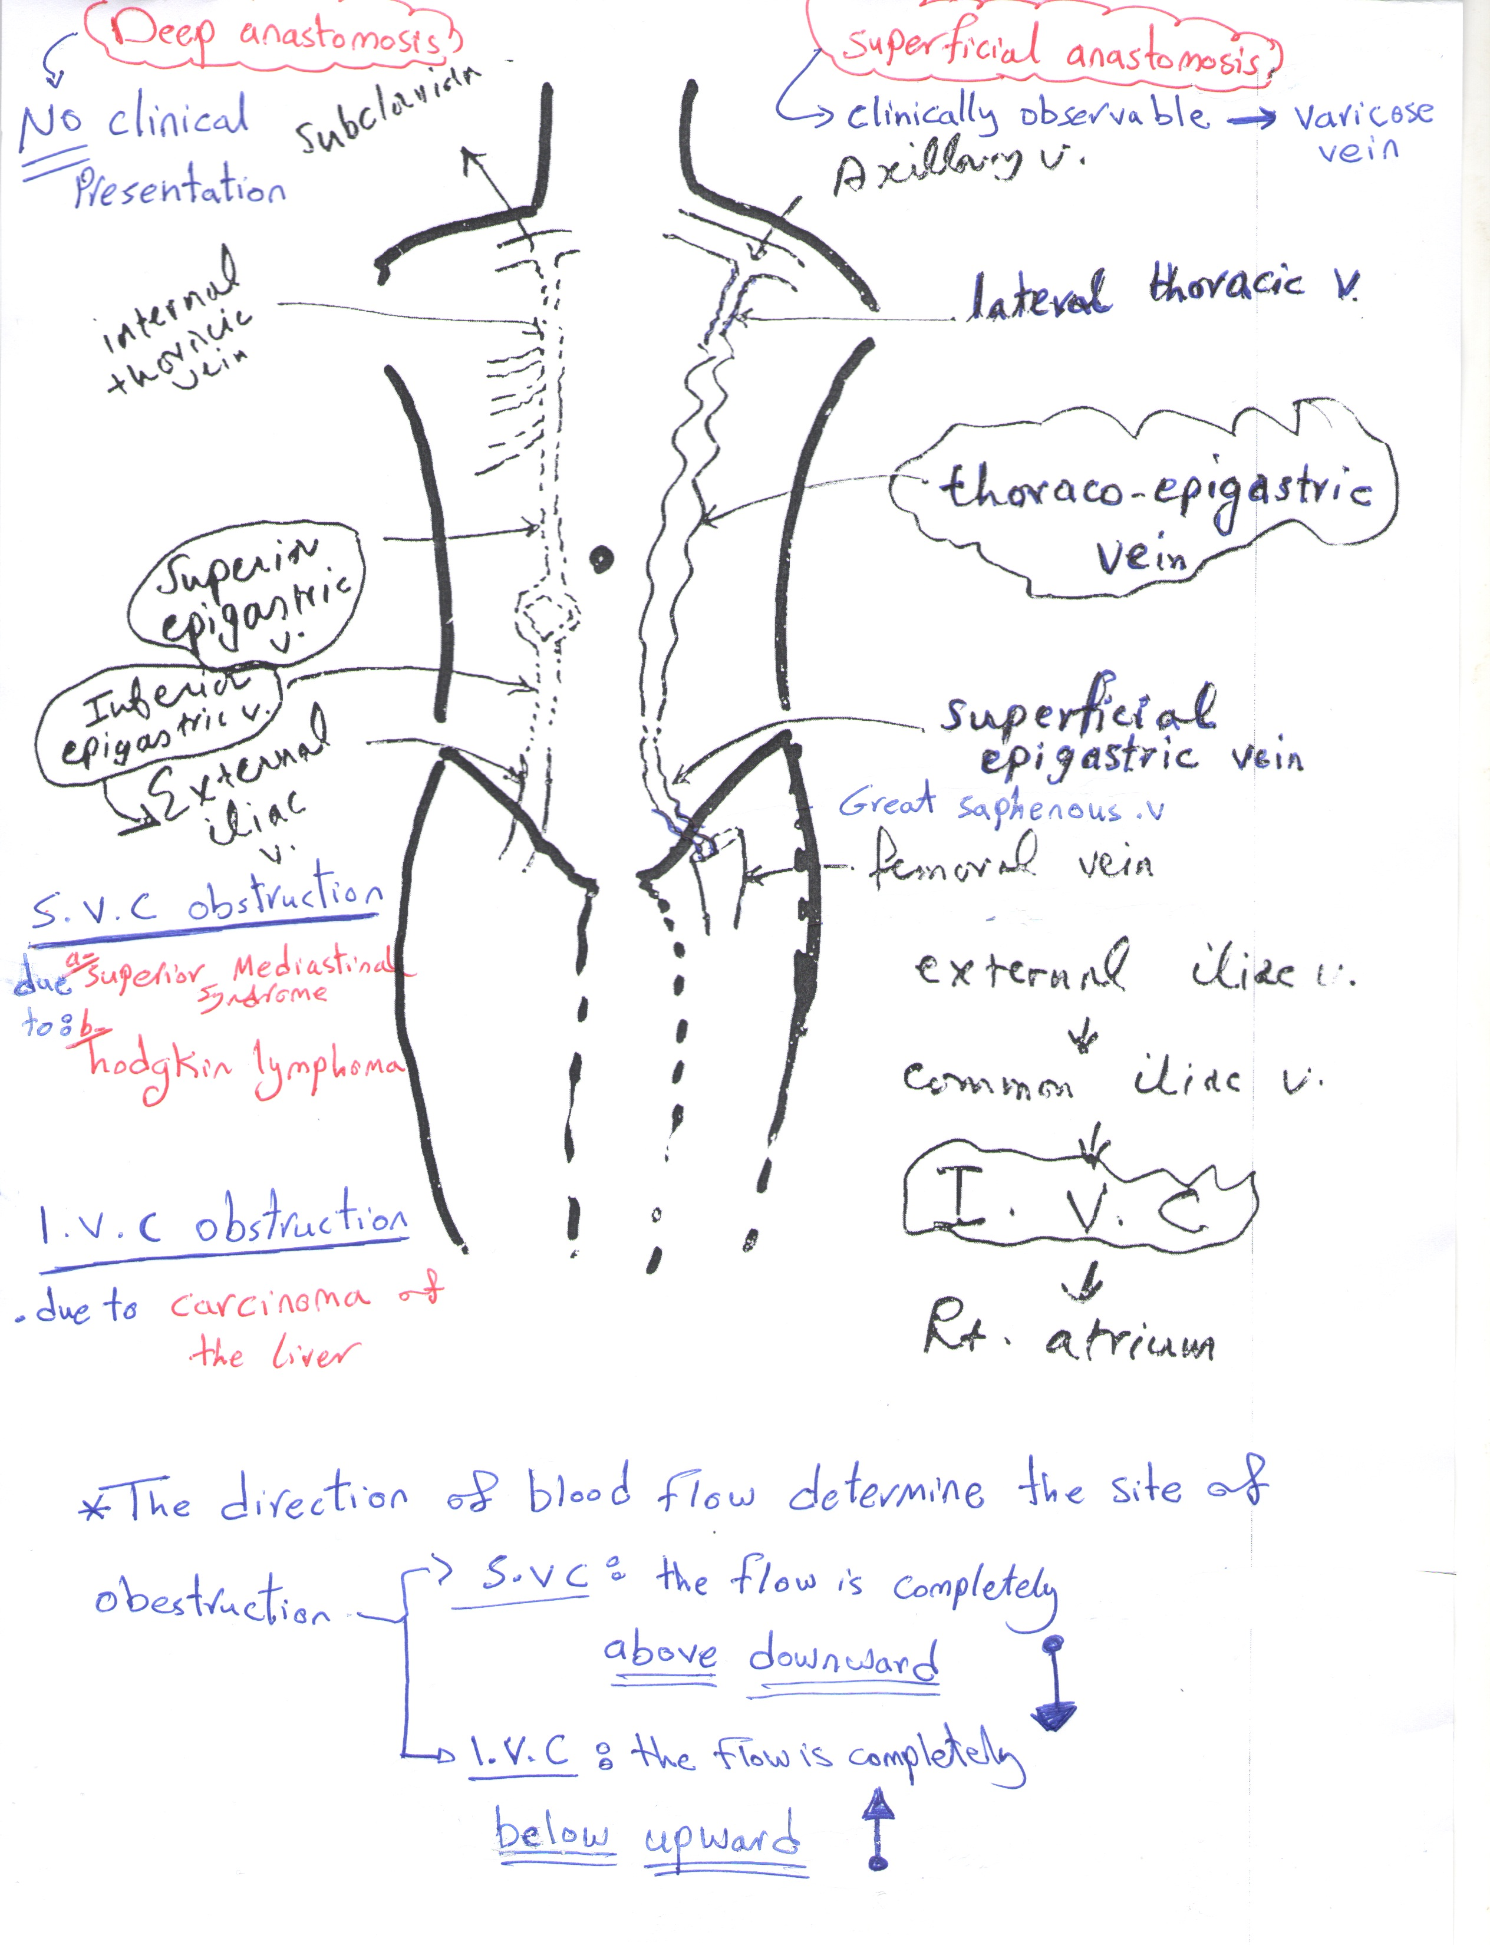

What goes around, goes around, goes around , Comes all the way back around ! …….. Justin Timberlake

Done by : DAWOOD AL- JANABY

