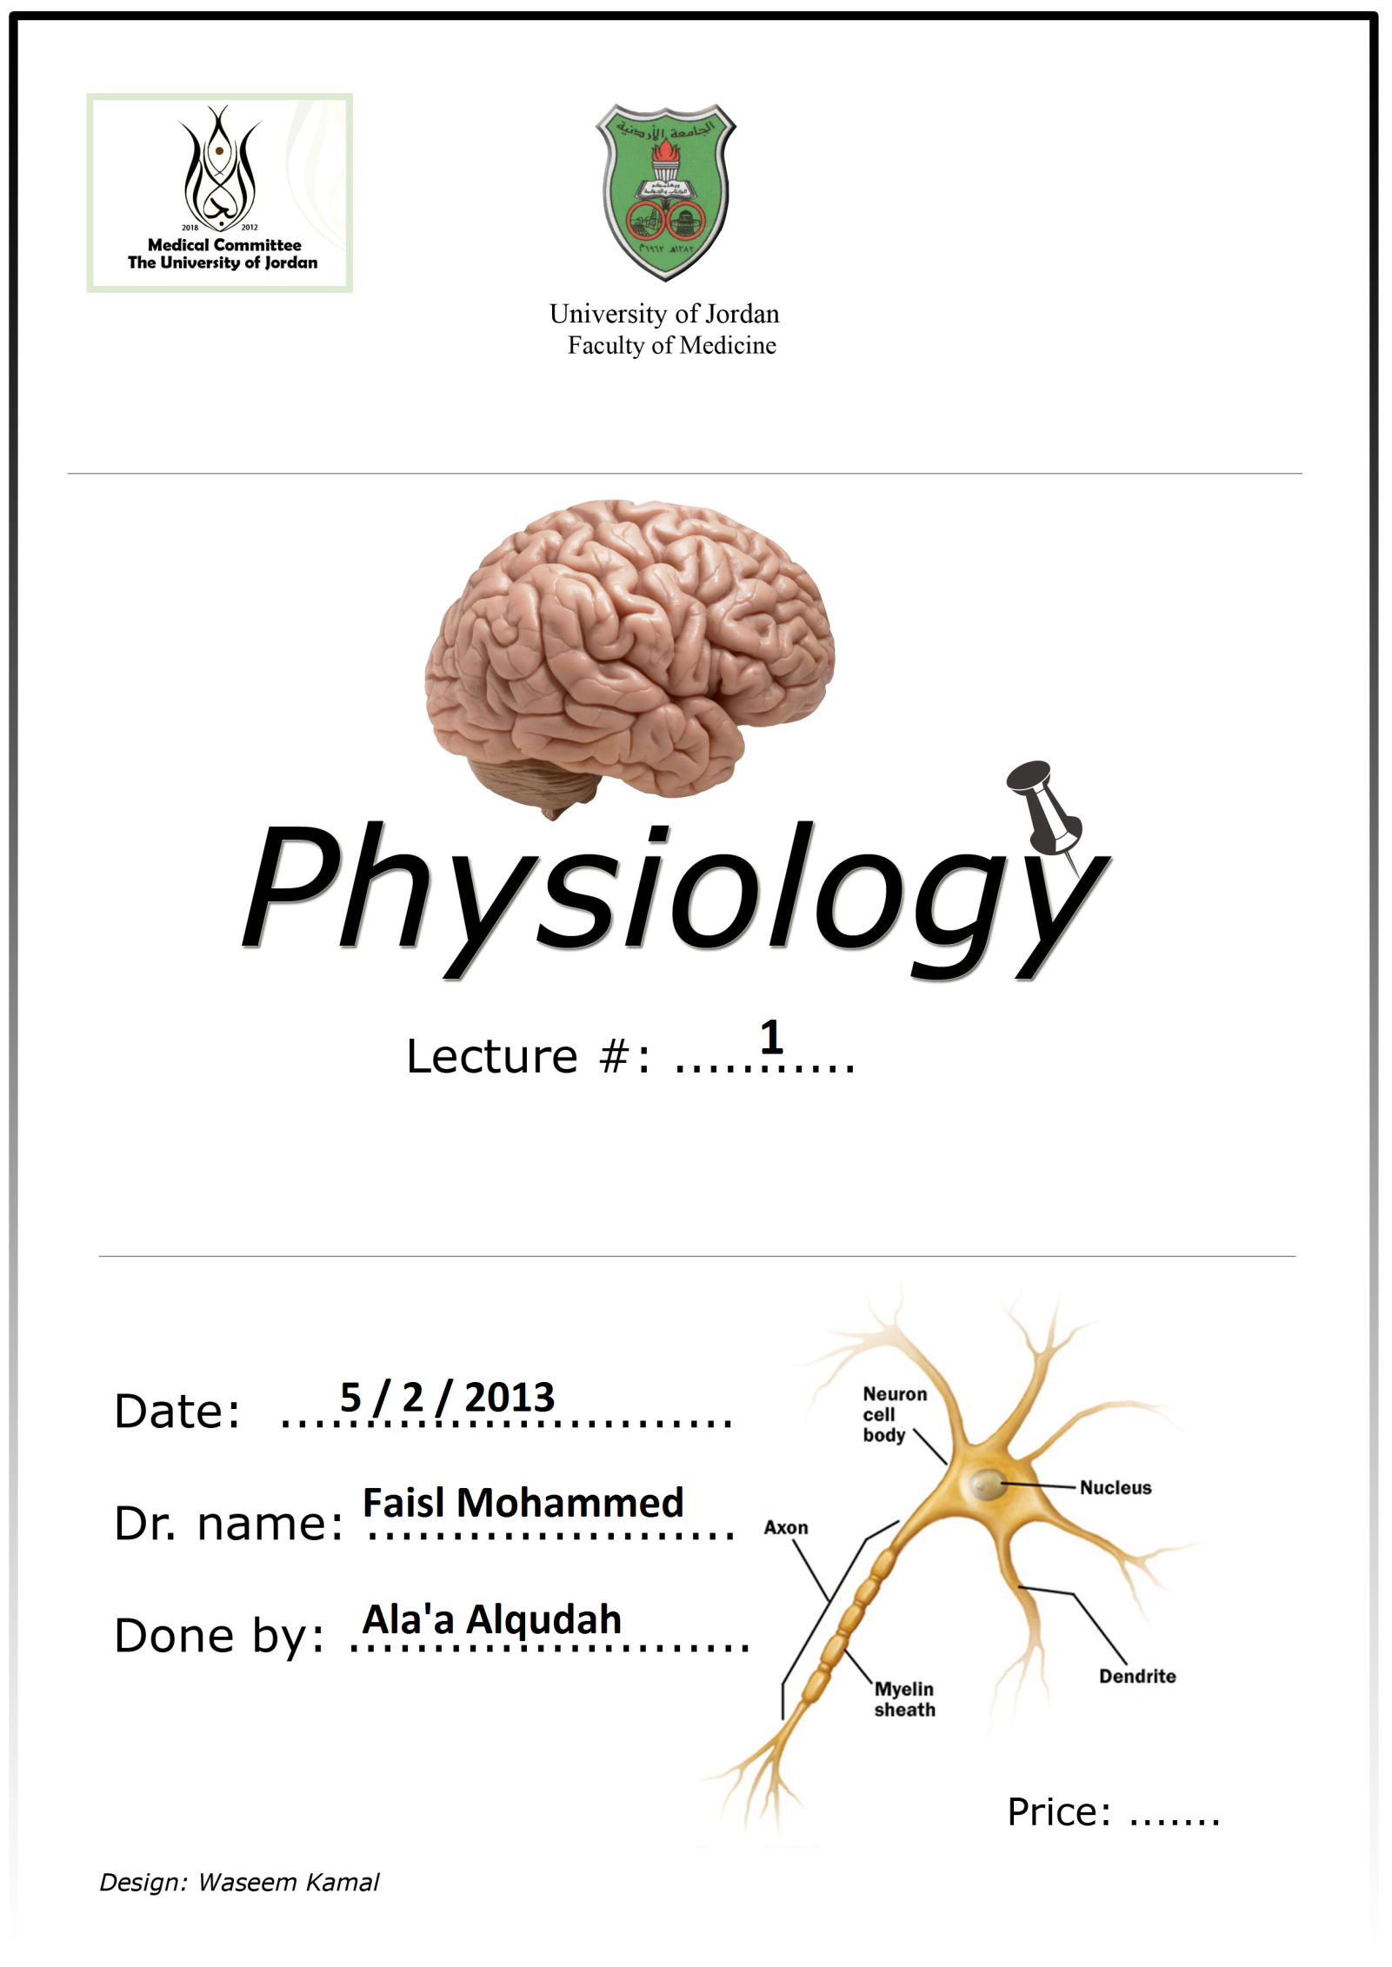

Physiology: is the science that deals with functions of the human body systems and the relations between these systems. [Normal physiology]
Whereas Anatomy is the science that deals with the structure.
All Human beings start from a zygote (diploid cell)-
-The zygote can absorb nutrients from the surrounding Fluid and get rid of its wastes by releasing them to this fluid.
-As this Zygote starts division, when it reaches a certain number of cells (large number), -As this Zygote starts division, when it reaches a certain number of cells (large number) it starts using Channels to exchange materials then these channels are developed into specialized systems.
-The multicellular human's body is composed of: systems -> each system is composed of organs -> these organs are made of specific tissues >> the tissues are composed of specific cells.

The Human Body Systems:
1 – The circulatory system: (cardio-vascular system + Blood)
2 – Respiratory system
3- Urinary system
4- Digestive system
5- Musculoskeletal system (muscular & skeletal system)
6- Integumentary system (skin)
7- Immune system
8- Reproductive system:
Nervous system >> electrical impulses
Endocrine system >>Hormones

9- Control system

(Check the slides 3&4)

All these systems cooperate with each other, to provide Homeostasis
Homeostasis: The regulation in body systems to maintain an almost constant internal environment.

If Homeostasis is imbalanced then there is a disease!!

Any change in homeostasis stimulates the control system and then the control system works in a special mechanism to return into the normal condition.
** Reproductive system has no homeostasis!

Example:
Respond

Blood pressure decreases
(Vasodilation)
(Widening of arteries )

Negative Feedback

Stimulate

Baroreceptors sense the change in blood pressure
If the Blood pressure increases
The control system

Negative Feedback control means that the systems respond in a way that reverses the direction of the change: Increase >> Decrease & Vise versa.
Positive Feedback control is incompatible with life's control but in some exceptions it is the Normal condition (these exceptions will be mentioned later)
Another example is blood glucose increases the glucose receptor on the pancreases responds by increasing insulin, the insulin will go to the cells and increases the entrance of the glucose to the cell, then the concentration of the glucose decrease to the normal. [nervous control ]
- If it decreases the glucose receptor on the pancreases respond by suppressing insulin and secretion of glucagon that stimulates glycogen break down in the lever. [endocrine control]
The control mechanism could be nervous or endocrine or both.
Fluids occupy about 60 % of the body's weight!
* There are two types of fluids inside our bodies:
Fluid outside the cell (Extracellular fluid) ECF >>> About 40%
Fluid inside the cell (Intracellular fluid) ICF >>> About 60%
Vascular (plasma) -> ECF
Interstitial (internal environment) -> ECF

ECF

